Week 5 Data Visualization Lab

Jared Camillo (PID A59006923)

2022-02-03

# Week 5 Data Visualization Lab  
  
# Use "cars" data included with downloaded R package  
View(cars)

## Warning in system2("/usr/bin/otool", c("-L", shQuote(DSO)), stdout = TRUE):  
## running command ''/usr/bin/otool' -L '/Library/Frameworks/R.framework/Resources/  
## modules/R_de.so'' had status 1

plot(cars)  
  
# ggplot2 has already been installed on this device  
library(ggplot2)

## Warning in register(): Can't find generic `scale_type` in package ggplot2 to  
## register S3 method.

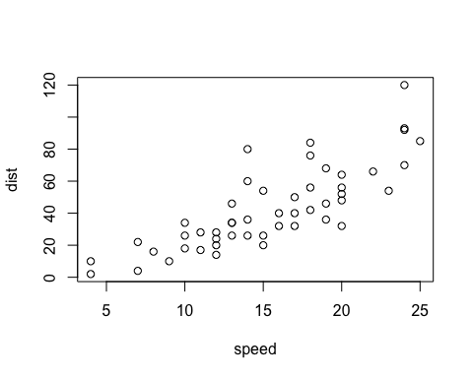

# Use ggplot to graph "cars" data  
p <- ggplot(cars) +  
 aes(x=speed, y=dist) +  
 geom_point()  
  
p

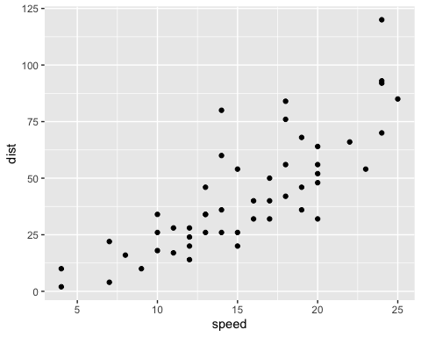

p + geom_line()

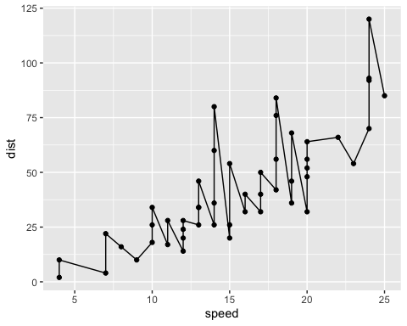

p + geom_smooth()

## `geom_smooth()` using method = 'loess' and formula 'y ~ x'

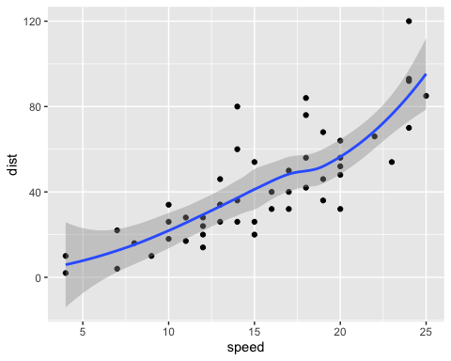

p + geom_smooth(method="lm")

## `geom_smooth()` using formula 'y ~ x'

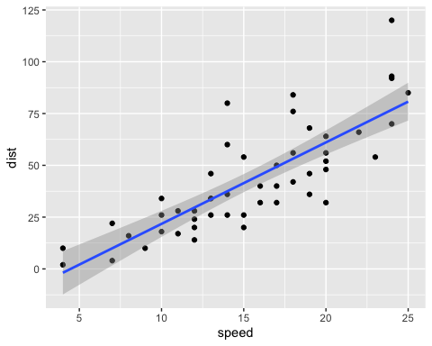

#Create plot using "iris" data)  
ggplot(iris, aes(x=Sepal.Length,  
 y=Sepal.Width,  
 col=Species)) +  
 geom_point()

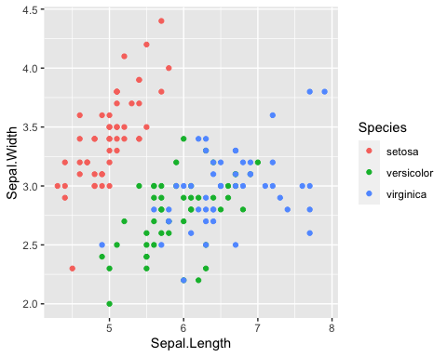

View(iris)

## Warning in system2("/usr/bin/otool", c("-L", shQuote(DSO)), stdout = TRUE):  
## running command ''/usr/bin/otool' -L '/Library/Frameworks/R.framework/Resources/  
## modules/R_de.so'' had status 1

# Import data from website and assign to "genes"  
url <- "https://bioboot.github.io/bimm143_S20/class-material/up_down_expression.txt"  
genes <- read.delim(url)  
head(genes)

## Gene Condition1 Condition2 State  
## 1 A4GNT -3.6808610 -3.4401355 unchanging  
## 2 AAAS 4.5479580 4.3864126 unchanging  
## 3 AASDH 3.7190695 3.4787276 unchanging  
## 4 AATF 5.0784720 5.0151916 unchanging  
## 5 AATK 0.4711421 0.5598642 unchanging  
## 6 AB015752.4 -3.6808610 -3.5921390 unchanging

# View "genes" data  
View(genes)

## Warning in system2("/usr/bin/otool", c("-L", shQuote(DSO)), stdout = TRUE):  
## running command ''/usr/bin/otool' -L '/Library/Frameworks/R.framework/Resources/  
## modules/R_de.so'' had status 1

nrow(genes)

## [1] 5196

table(genes$State)

##   
## down unchanging up   
## 72 4997 127

round((table(genes$State)/nrow(genes))*100, 2)

##   
## down unchanging up   
## 1.39 96.17 2.44

# Use ggplot to plot "genes" data  
g <- ggplot(genes)+  
 aes(x=Condition1,  
 y=Condition2,  
 col=State)+  
 geom_point()  
  
g

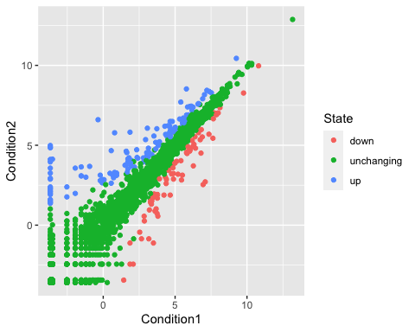

# Adjust ggplot of "genes" data  
g + theme_bw() +  
 scale_color_manual(values=c("blue","gray","red"))+  
 labs(x="Control (no drug)",  
 y="Drug treated",  
 title="Gene expression changes example plot")

